Introduction to Bayesian Statistics
Installing WinBugs

Downloading WinBugs
WinBUGS is free to download at the following website
http://www.mrc-bsu.cam.ac.uk/software/bugs/the-bugs-project-winbugs/

Note: This is to download WinBUGS for WINDOWS compatible devices. If you are using something else (Mac using WINE, Linux) you should download OpenBUGS which is compatible with those platforms (http://www.openbugs.net/w/Downloads). You are on your own after this.

Find the link to download the executable file for WinBUGS14 under the Quick start menu.
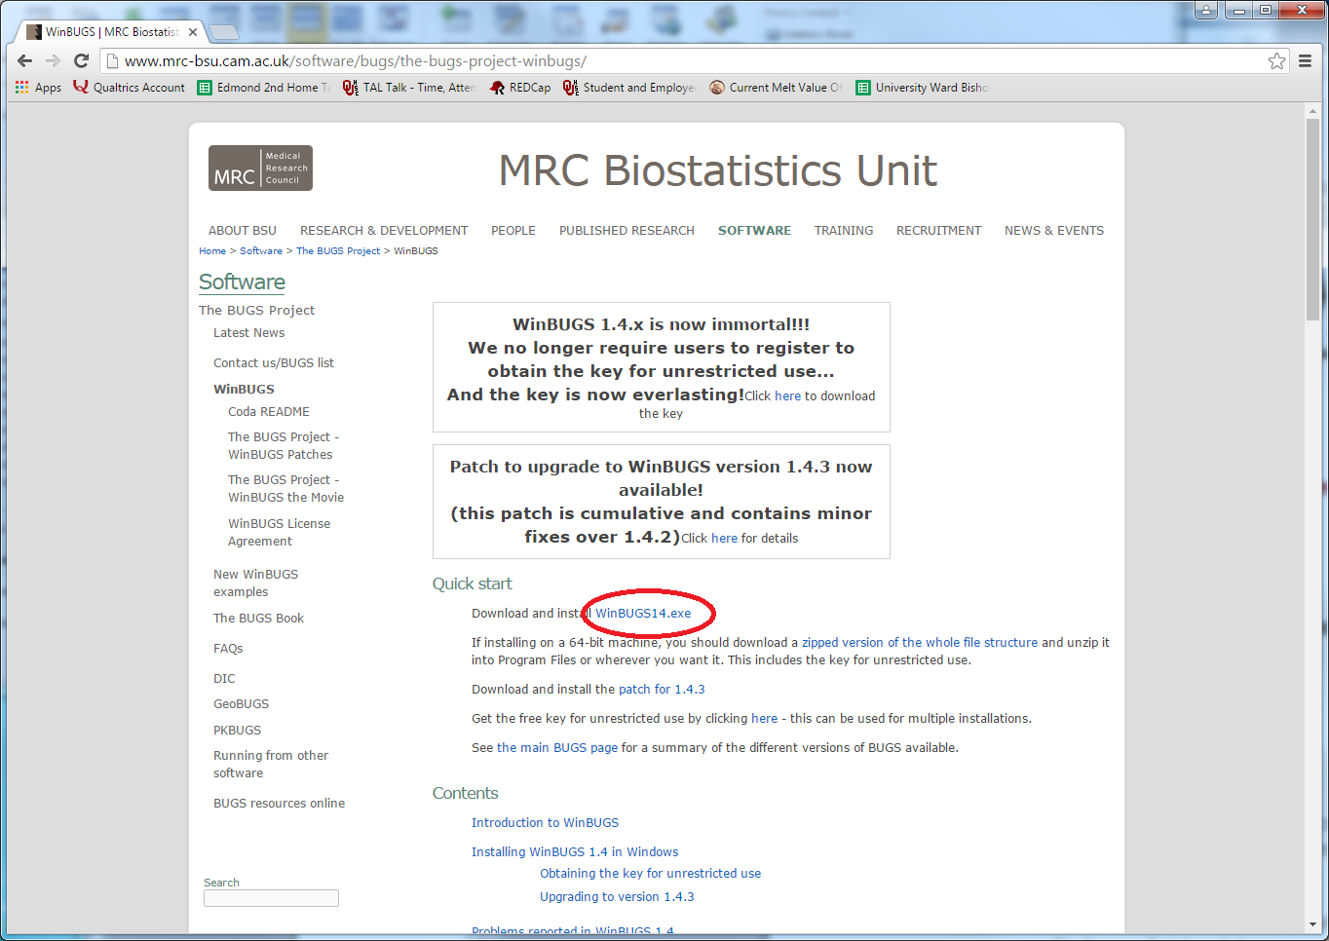
Note: if you would like to download the 64 bit version, follow the directions underneath those given above and download the zipped files which include all of the keys (more on these in a moment) for activating WinBUGS.
After the download completes you should see the following dialogue box
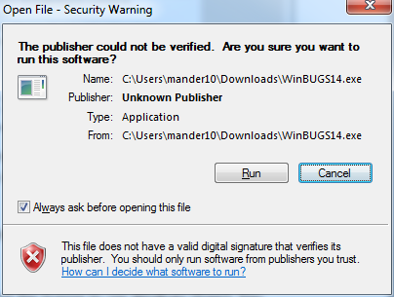
Select ‘Run’ and the follow the on screen directions for the installation process. Note that you may select where you want WinBUGS installed. The website suggests installing Program Files but you may really install this anywhere you’d like.

Open and Activate WinBugs
Once WinBUGS is installed, you may find it in the directory you specified (or with the desktop icons if you so selected) and open it. You should see the window below
Go to the File menu and select ‘New.’ A fresh blank WinBUGS page should appear over the License Agreement called ‘untitled1.’
Now go back the website where you downloaded the WinBUGS14 executable and find the link to the key to activate WinBUGS.
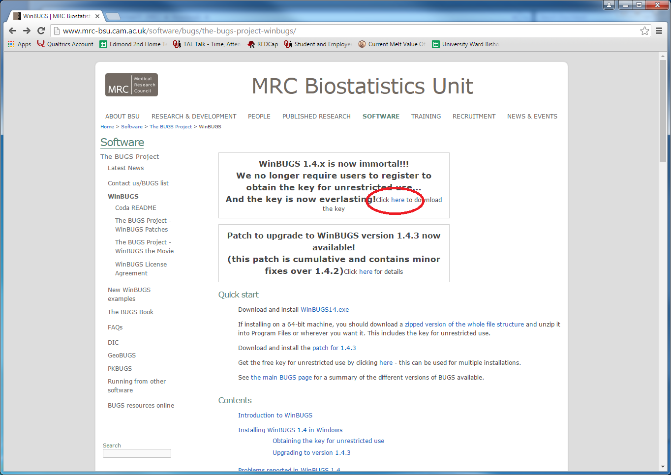
This will bring up a page with lots of strange code and characters on it like the one below.
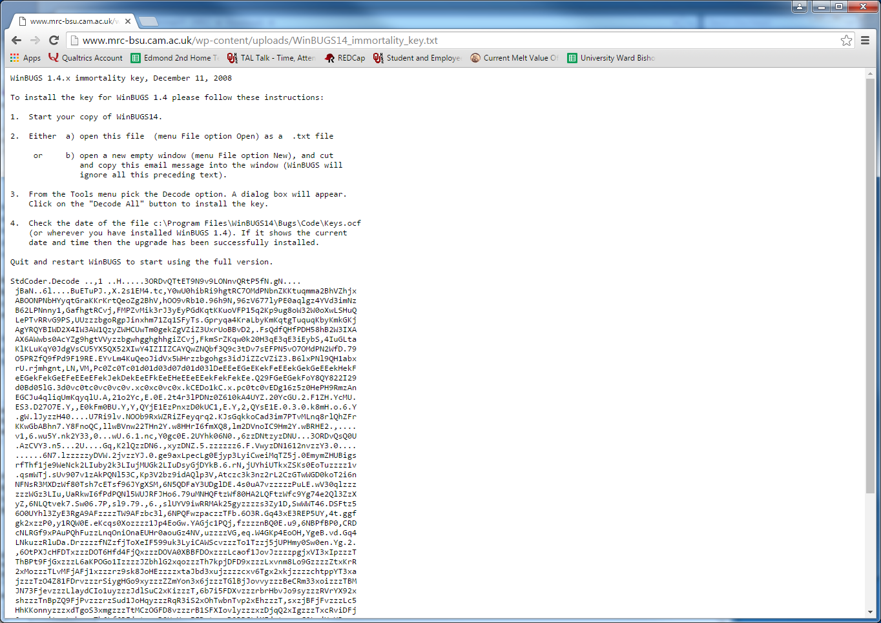 Select all (ctrl+a), copy all (ctrl+c), and paste (cntrl+v) into the ‘untitled1’ in the WinBUGS program.
Now from the Tools menu in WinBUGS select ‘Decode.’ Choose ‘Decode All’ to install the key.
Quit and restart WinBUGS and you should be ready to go!

